**PROJECT WORKING SPACE**

For statement of work (SOW) and project timelines: [here](https://github.com/phamtaiece/Capstone-Sightline/blob/master/General%20Documents/SIGHTLINE_SOW%20(Final).docx)

**SLA Hardware Specification and Assembly**

**SLA – hardware:**

* 1500 OEM Rev E included:
* programmed SOM
* firmware 2.25.05 [FPGA ver. 10]
* 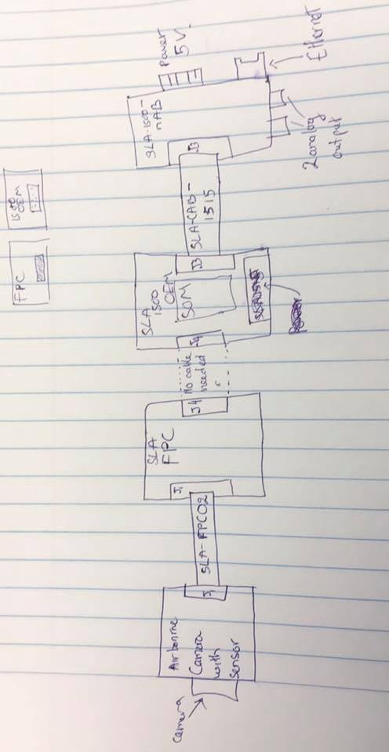license 0xFFFF
* heatsink on the top
* 1500 - SLA - nAB rev A
* 1500 - SLA-FPC Rev B
* SLA – 1500 – CASE
* Airborne camera (Mono camera) and sensor

**Assembly:**

The picture below is how pieces are connected together.

Fig 1. Basic assembly and connection

SLA-FPC 02: CABLE FFC 39 POS 0.3 MM 2” - part#: 150150239 -DigiKey

SLA-CAB-1515 – Specialize at Sightline (no part #)

J1: 39-POS, 0.3 MM – Molex – part #: 501912-3990

J4: part #: DF12B(5.0)-50DP-0.5V(86) [CONN header 50 POS 5MM SMD 0.5MM – Hirose] from 1500 OEM  
CONN RECEPT 50POS 0.5MM GOLD SMD DF12-50DS-0.5V(86) from 1500 – FPC.

J3: CONN header 14POS 1.25MM VRT SMD – Molex – Part# 53398-1471

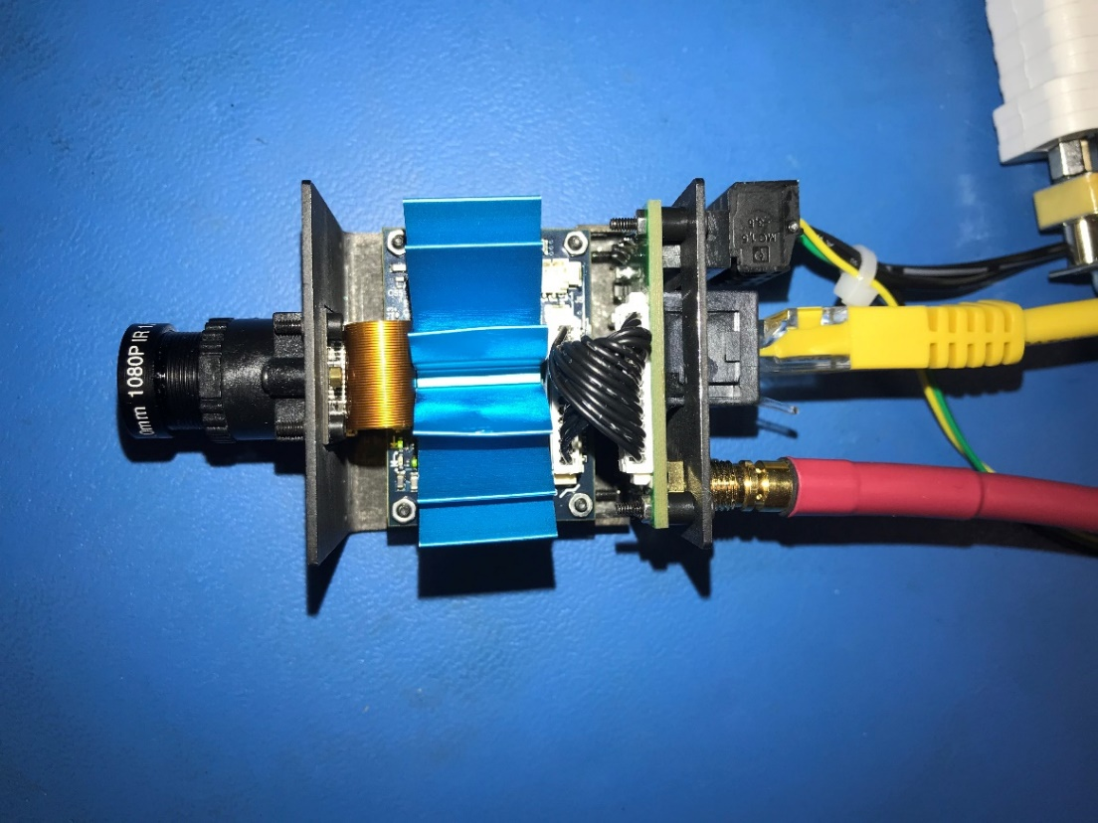

Fig 2. Assembled SLA hardware. Those external cables are: Ethernet, Analog out, and 5V power.

**The hardware has been tested successfully.**

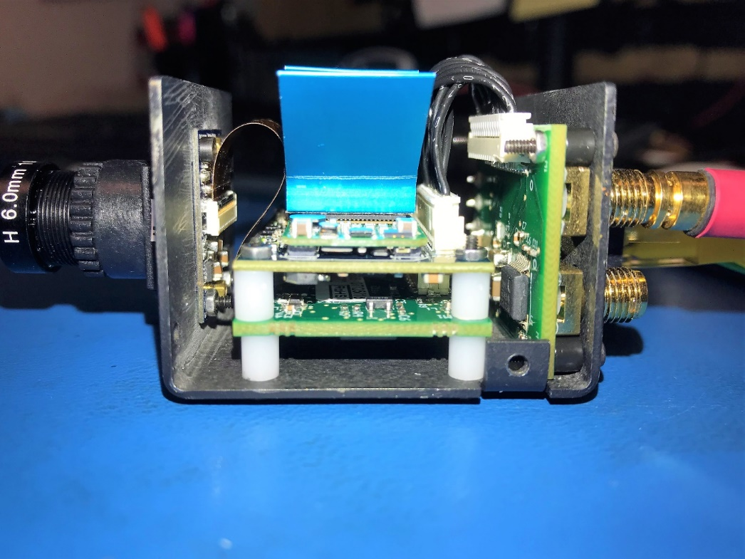

Fig 3. Assembled SLA hardware

**Pixhawk 4 Initial set up (Tai)**

Pixhawk 4 is powered from USB cable.

Issue 1: My laptop, ASUS windows 10, can’t recognize the device, Pixhawk 4. I uninstalled the software (Qgroundcontrol, PX4 driver) and installed again. It still didn’t work. The problem might come from the USB port from my laptop.

**Temporary solution:** I used Sightline’s computer to install Qgroundcontrol and PX4 driver. Yes, it works normally. The Sightline’s computer is Windows 10 pro.

**Open Qgroundcontrol:** Those initial set up and calibrate are done in Qgroundcontrol interface.

**Pixhawk 4 fimware**: updated to latest version.

**Airframe**: Calibrated for Quadcopter DJI F450

**Sensor**: Calibrated

**Radio:**

Radio control set up consist of two main steps: binding Radio Control (RC) transmitter to X4R receiver and connecting X4R receiver to the Qgroundcontrol. This procedure is carefully followed by using FrSky RC manual and X4R radio receiver manual.

**Radio Control model name**: X9D Plus

**Radio receiver**: X4R SB

**Connecting X4R receiver to Qgroundcontrol**:

The X4R package has a Smart port 4-pin connector with three pin out, unfortunately, there is no traditional 3 pin on the Pixhawk 4. However, the Pixhawk 4 has 5-pin molex SBUS RC and 5-pin molex DSM RC which can be able to connect with X4R via 3 pin header.

Before connecting the X4R with Pixhawk 4, please read the Pixhawk 4 pinout document (<http://www.holybro.com/manual/Pixhawk4-Pinouts.pdf>). I used the **SBUS RC 5 pin molex** to connect with X4R on the **bottom 3-pin header** connection (SB + -). While connecting the SBUS RC 5 pin to the X4R, hold the **F/S button** on X4R to enter the binding mode. After connecting the SBUS RC cable to X4R, continue to hold the F/S button and turn on the Radio Control Transmitter.

Release the F/S button. On X4R, we will see the **green light is on, and the red led is flashing** which is indicating the binding mode is ready.

**Binding radio control transmitter to X4R procedure**:

Turn on your radio (which has done in previous step) and skip those starting-up warning by press **exit button**.

Press **Menu button** and choose the model that you want to operate. I choose the first model and changed its name to “**DJI F450**”.

Press **enter** choose to the model, press **Page** to open the model description.

Use **+ button or – button** to move up or down.

Move to the **Internal RF** option, and choose the following:

**Mode: D16**

**Channel Range: CH1-8**

Move the cursor to [**Bind**], and press **Enter**. You will hear the **bird chirping sound** which indicated the binding was successful. Now **power cycle** both radio control transmitter and the X4R receiver.

The X4R now will have a **green LED light ON**, indicated that the X4R is ready to receive the command from the RC transmitter.

Now, follow the guidelines on Qgroundcontrol to complete radio setup.

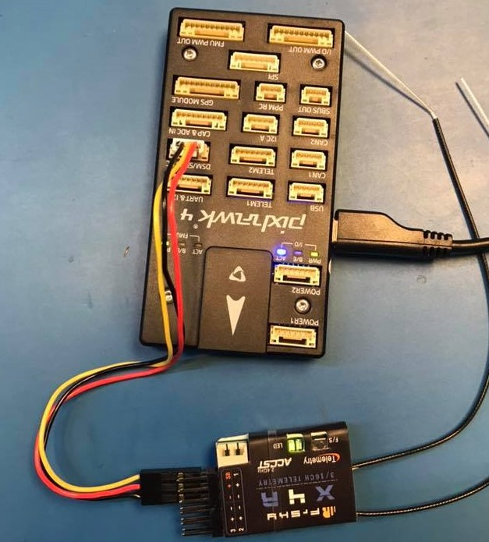

Fig 4. X4R connected to Pixhawk 4 via SBUS port. Green light on indicated binding successfully

**Flight mode**: I only set up some basic configuration below.

Mode channel: Channel D16

Fight mode 1: Altitude

Flight mode 2: Position

Flight mode 3: Stabilized

Flight mode 4: Hold.

More set-up will need to add along way when we test the drone with Radio control.

**GPS**

GPS is connected successful. Move the Pixhawk 4 will move the vehicle indicator on Qgroundcontrol.

**Silk Telemetry radio Wireless:**

One connected to the pixhawk 4 via TELEM1 port, one connected to computer using USB port.

Temeletry radio updated to MAVLINK 2.0.

Two telemetry radio communicated with each other.

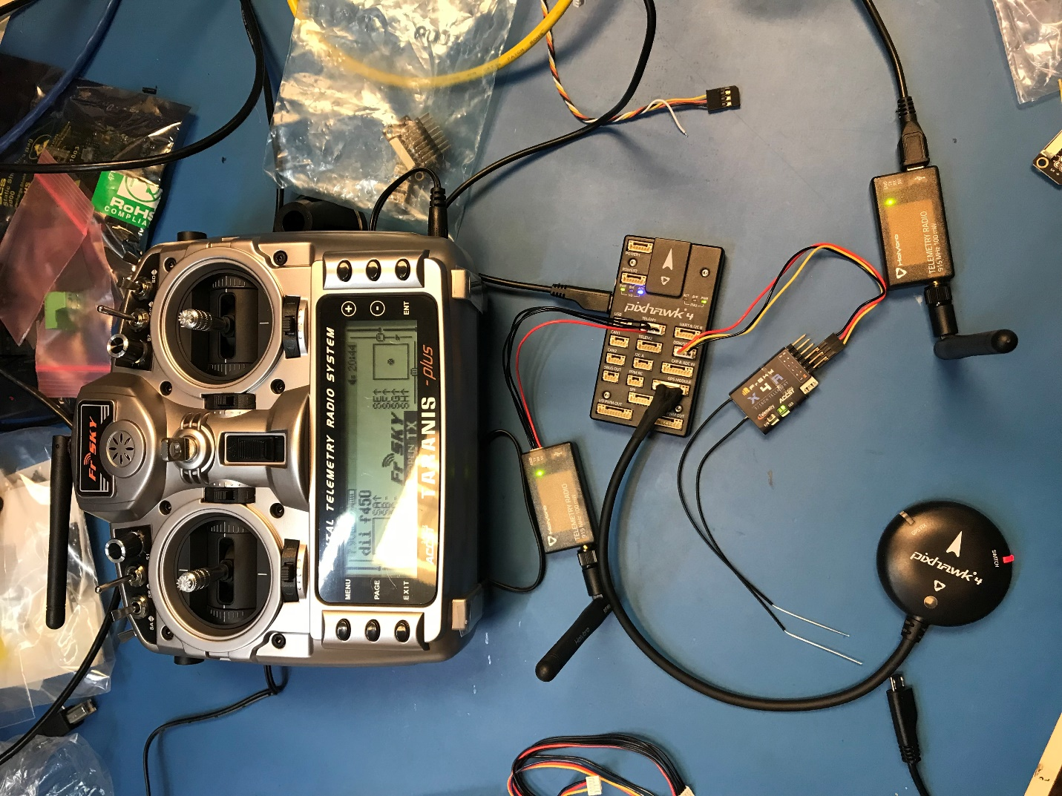

**Fig 5**. Completed initial set up and calibration. Pixhawk 4 is connected with X4R radio receiver via SBUS port. Telemetry radio is connected with Pixhawk 4 by TELEM1. Another Telemetry radio is connected to Qgroundcontrol via USB port. GPS is connected to GPS port.

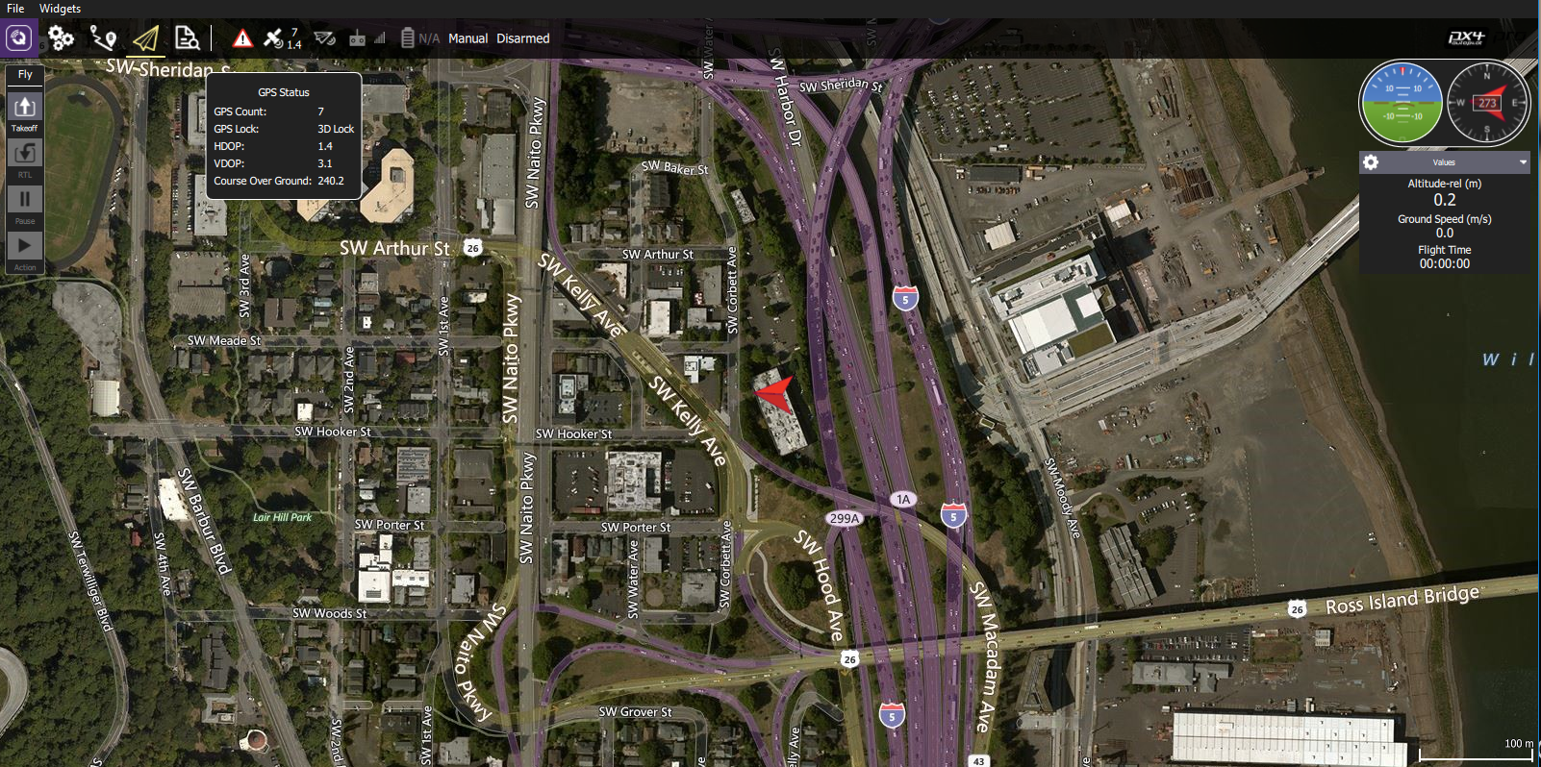

Fig 6. Qgroundcontrol interface. The red arrow is vehicle indicator. Qgroundcontrol showed us altitude, speed, direction, as well as flight mission.

The Qgroundcontrol is ready to flight, it might actually need to do “flight internal check.” The next step could be connected the Quadcopter with Pixhawk 4 and Power management board. We are ready to fly.

**Airframe: Quadcopter DJI Flame Wheel F450 Assembly (Kimball)**

The assembly instructions from the  [DJI F450 user manual](http://dl.djicdn.com/downloads/flamewheel/en/F450_User_Manual_v2.2_en.pdf) were more of an assembly diagram.

The following shows step by step how the F450 frame was assembled for the project.

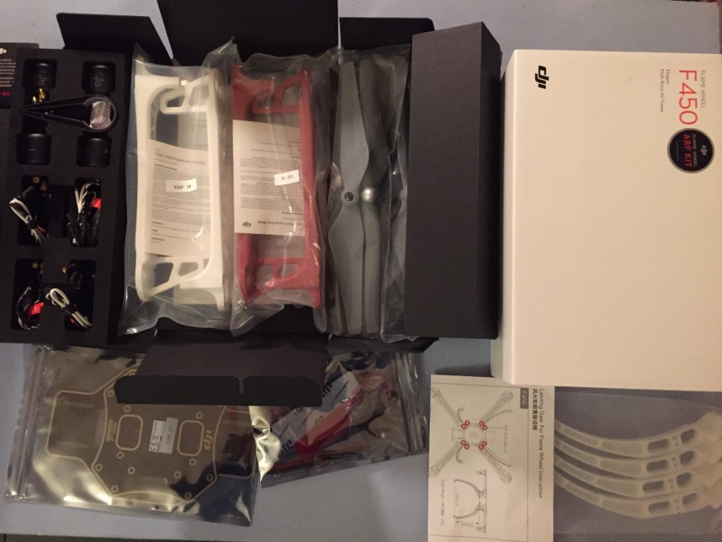

Figure 1 DJI F450 kit

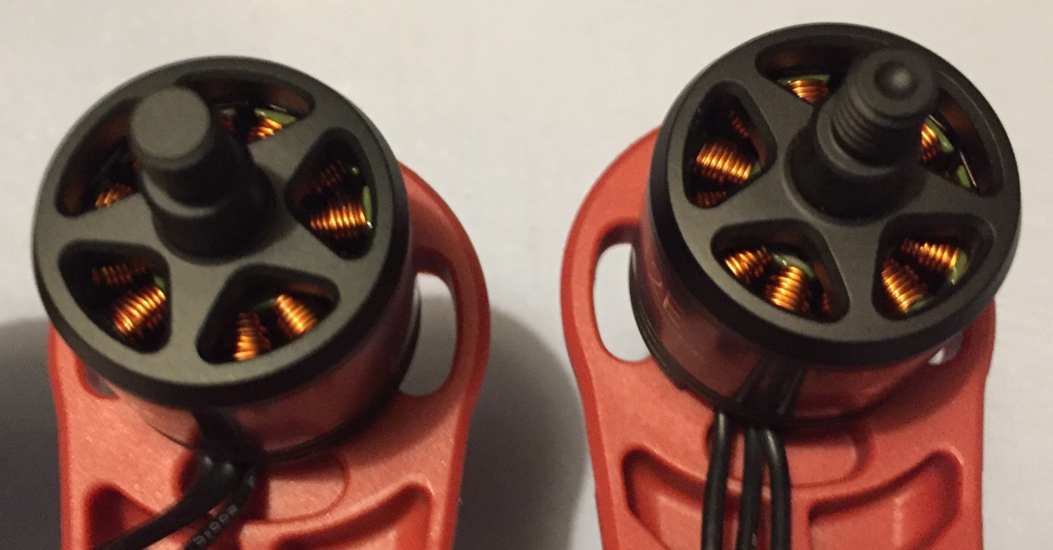

Figure 2: In the kit there are 2 clockwise motors and 2 counter clockwise motors. The CW motors have a dimple on the rotor shaft the CCW motors do not.

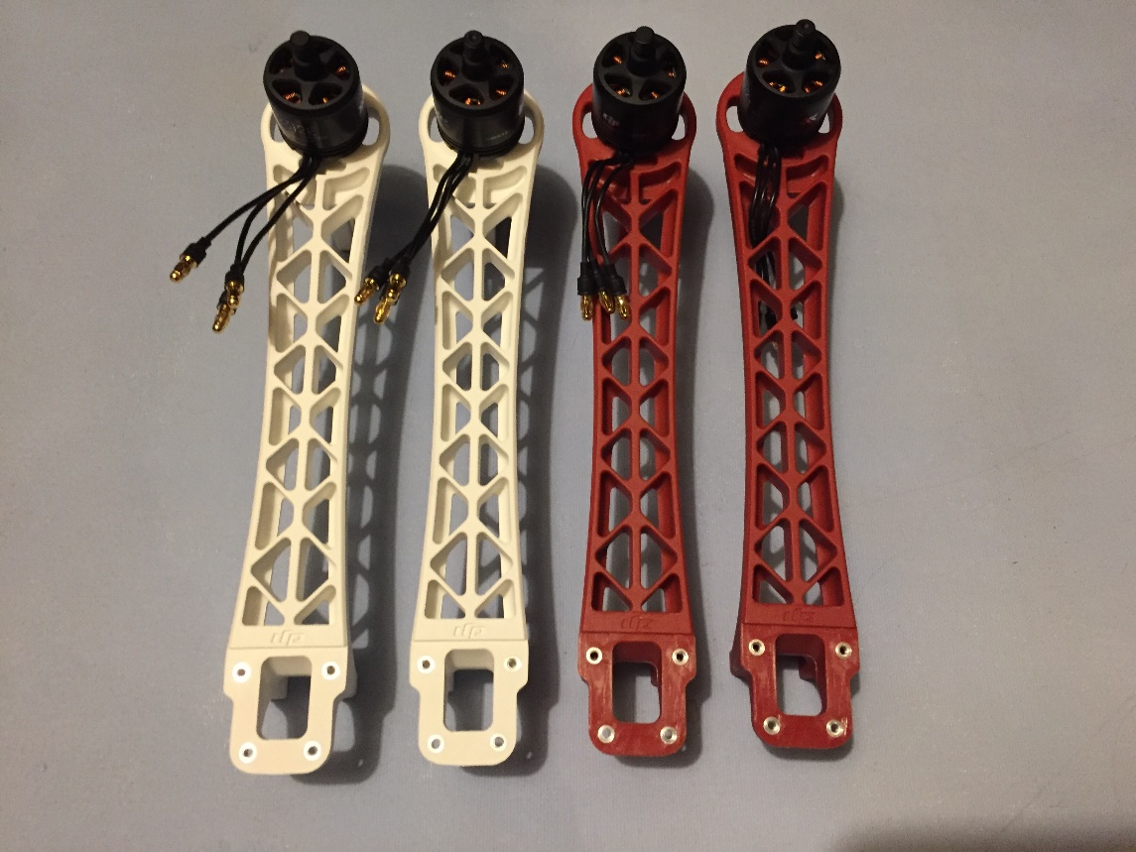

Figure 3: The motors were attached to the arms with the screws provided with the motors oriented according to the user manual.

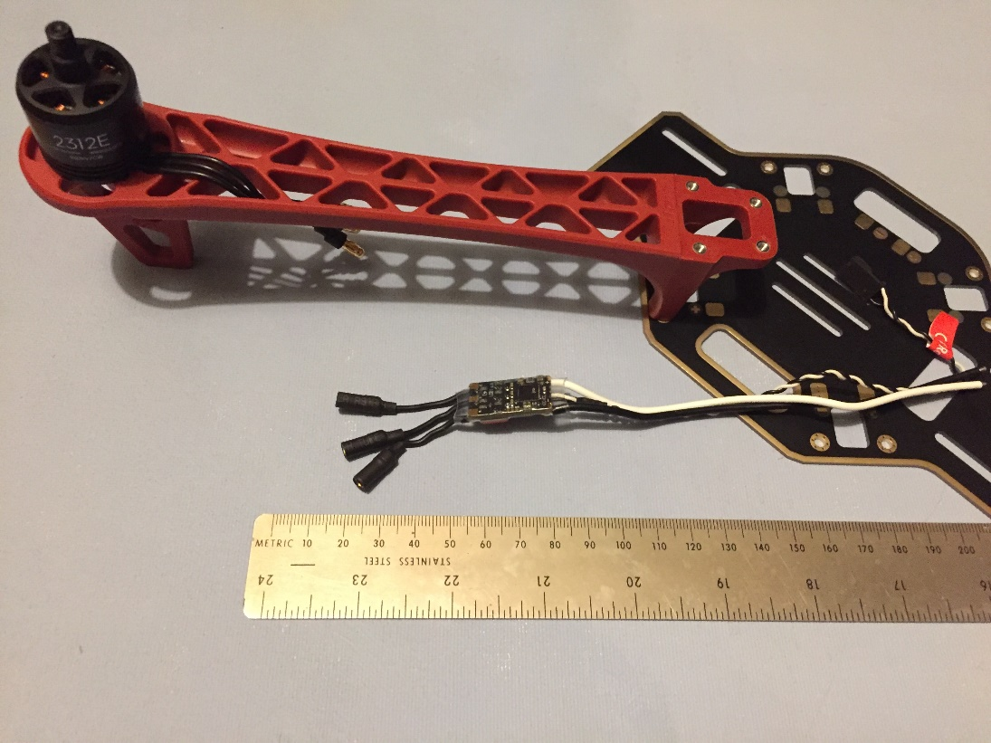

Figure 4: The ESC length was measured to get rid of any additional slack

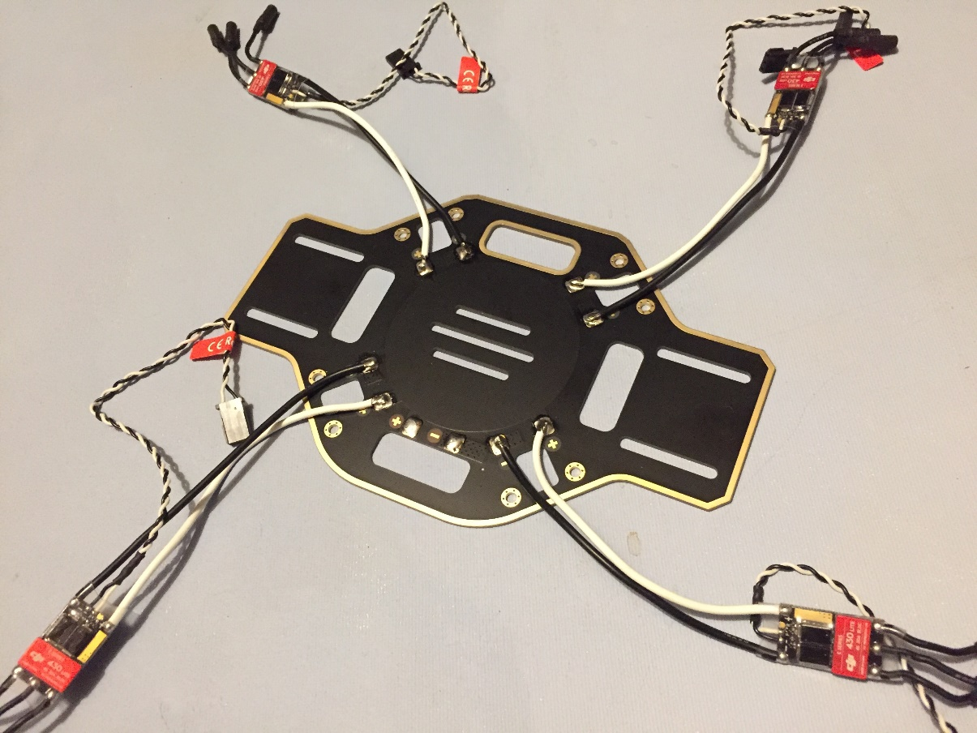

Figure 5: The ESC wires were cut to length then soldered to the base plate.

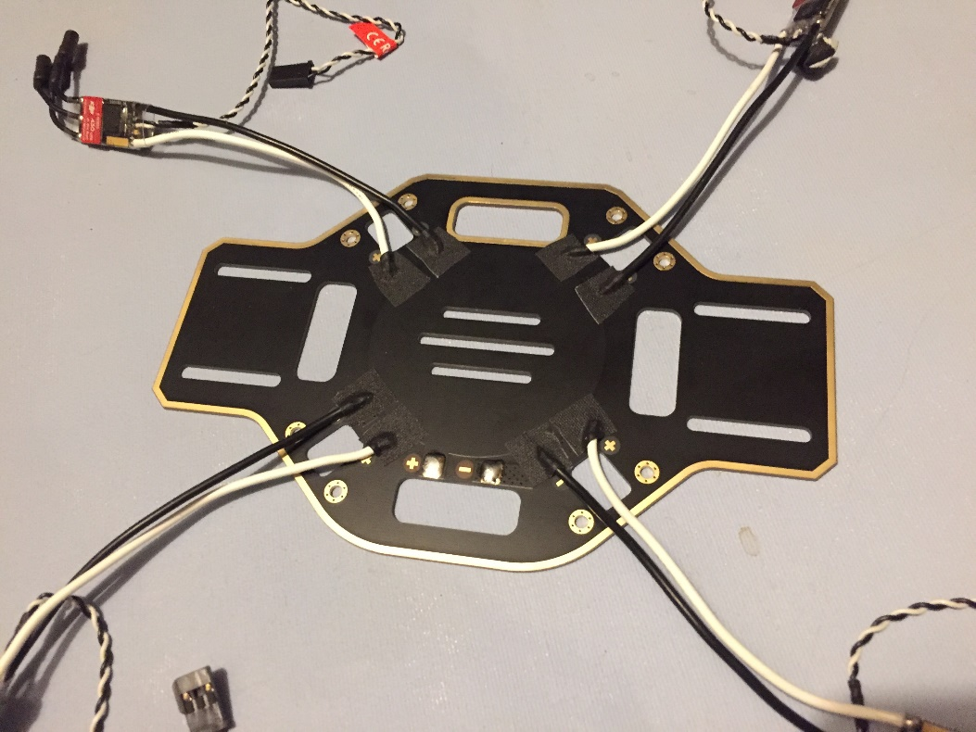

Figure 6: Insulating tape was applied over the solder joints.

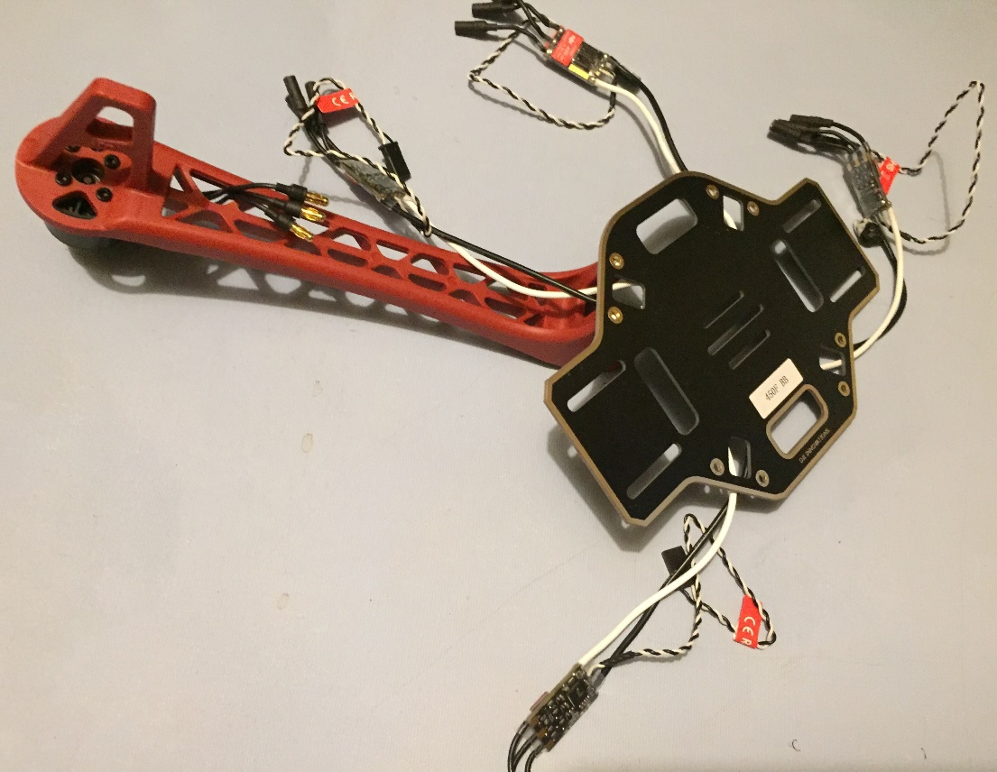

Figure 7: The base plate was flipped over onto one of the red arms, again the motor orientation from the user manual was observed. The arm shown has a CW motor attached.

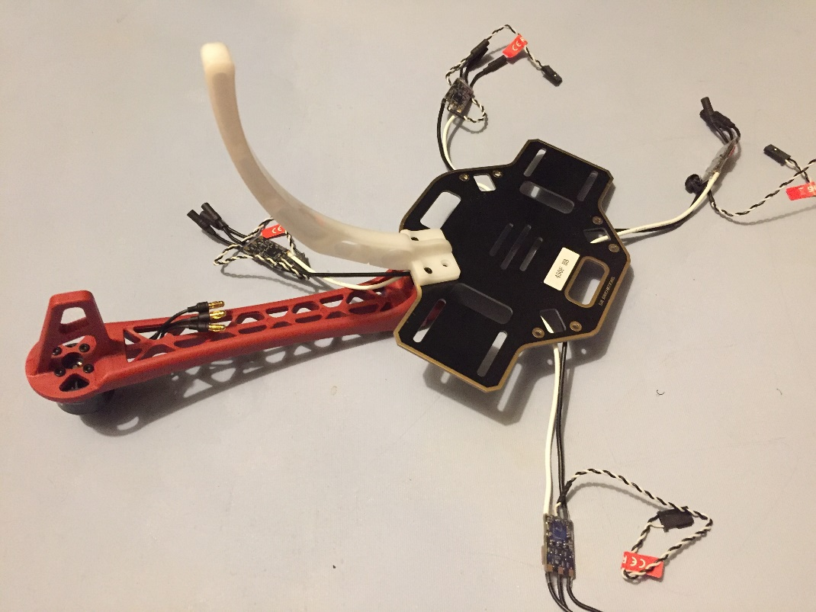

Figure 8: The landing gear and the frame arms are attached to each other with two screws through the base plate.

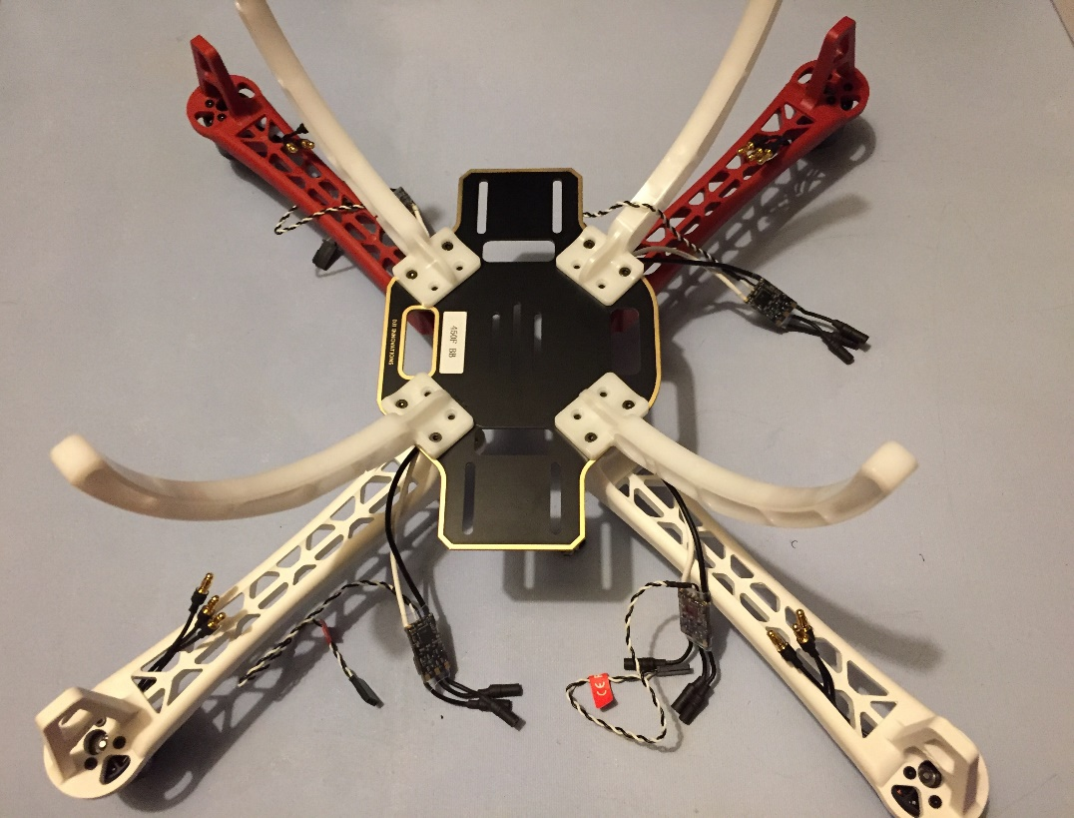

Figure 9: The process was repeated for the remaining three sets of arms and landing gear making sure to orient the CW and CCW motors according to the user manual.

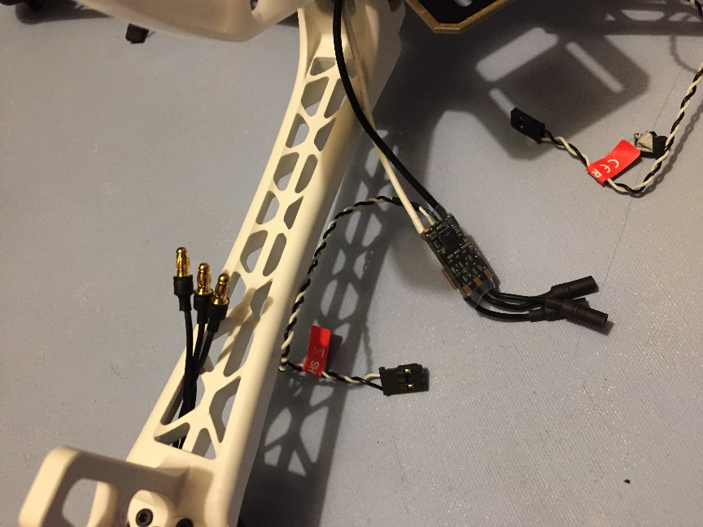

Figure 10: The ESC’s were connected to the motors and the wires secured to the frame with zip ties as shown below.

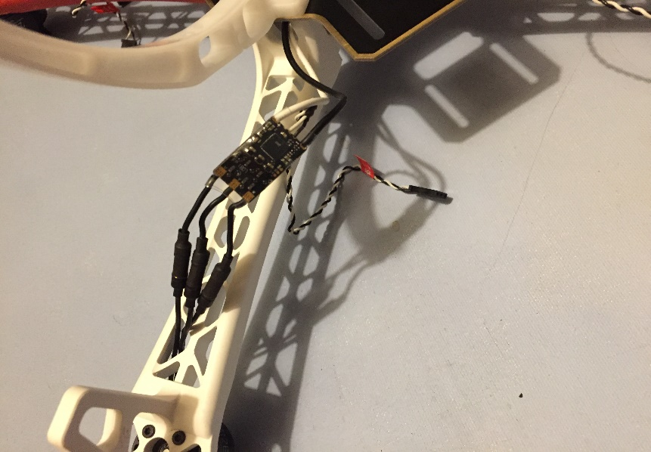

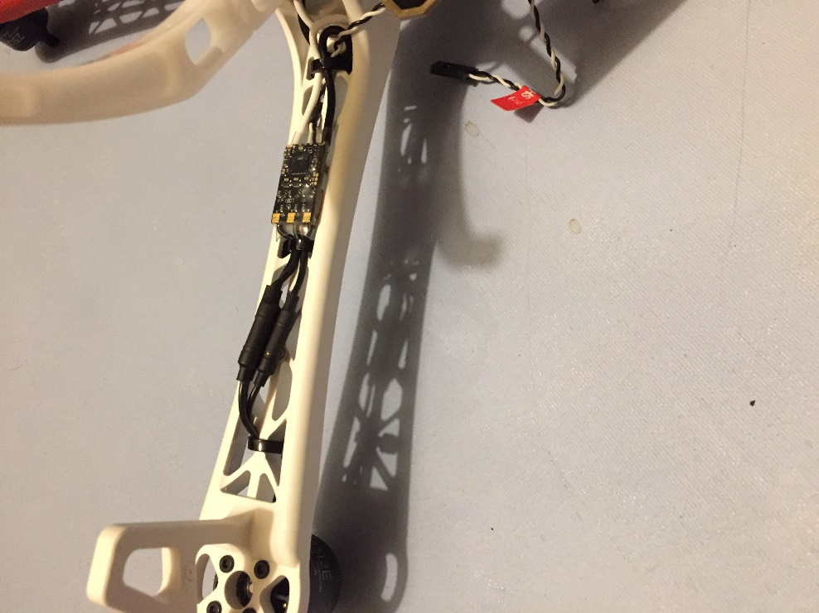

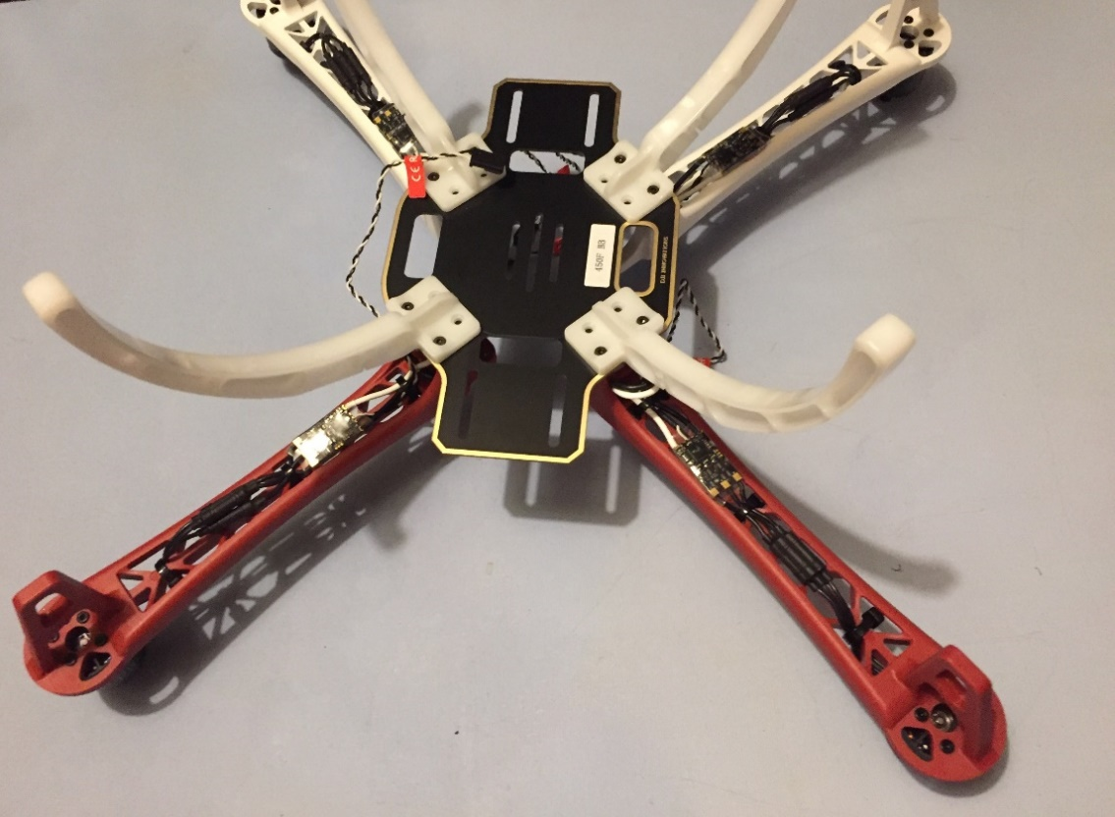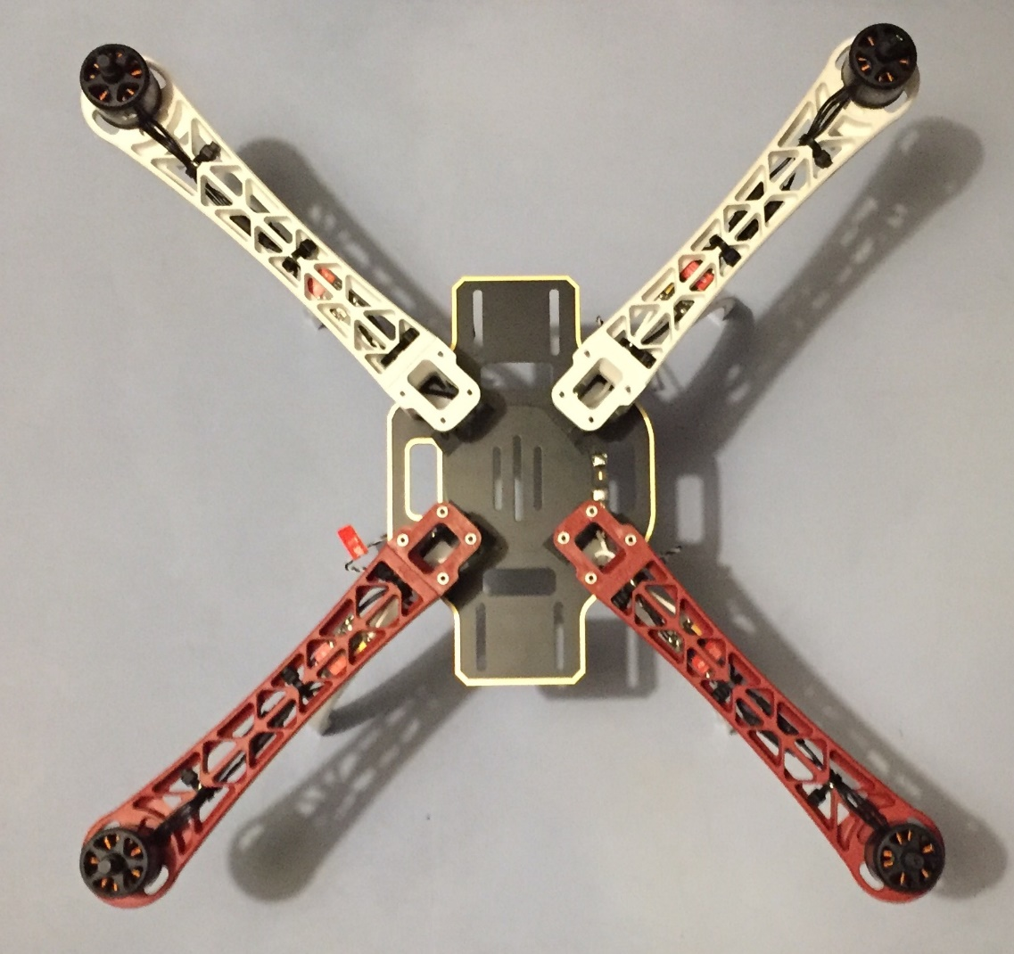

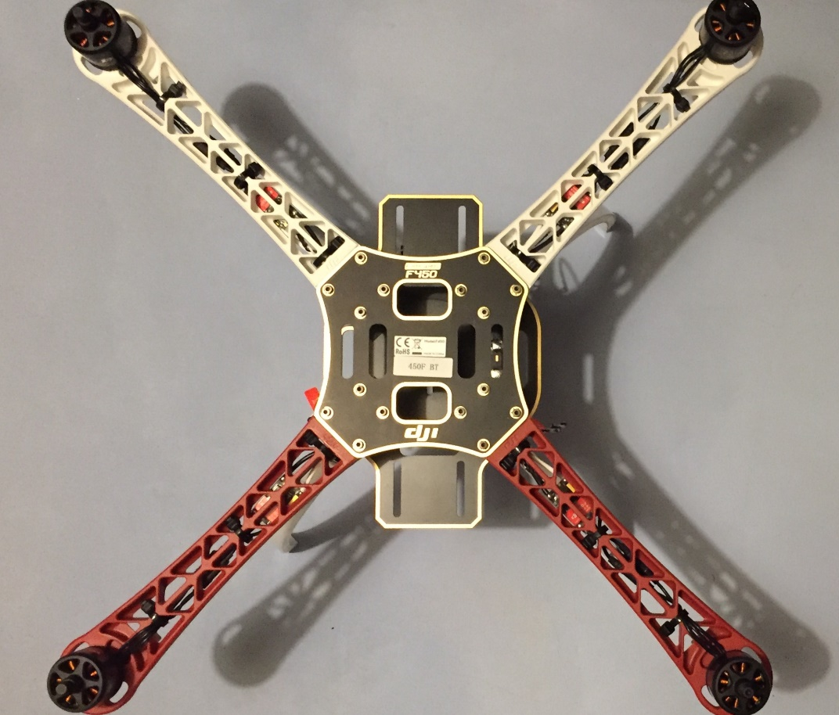

Figure 11: The top frame plate was then attached.

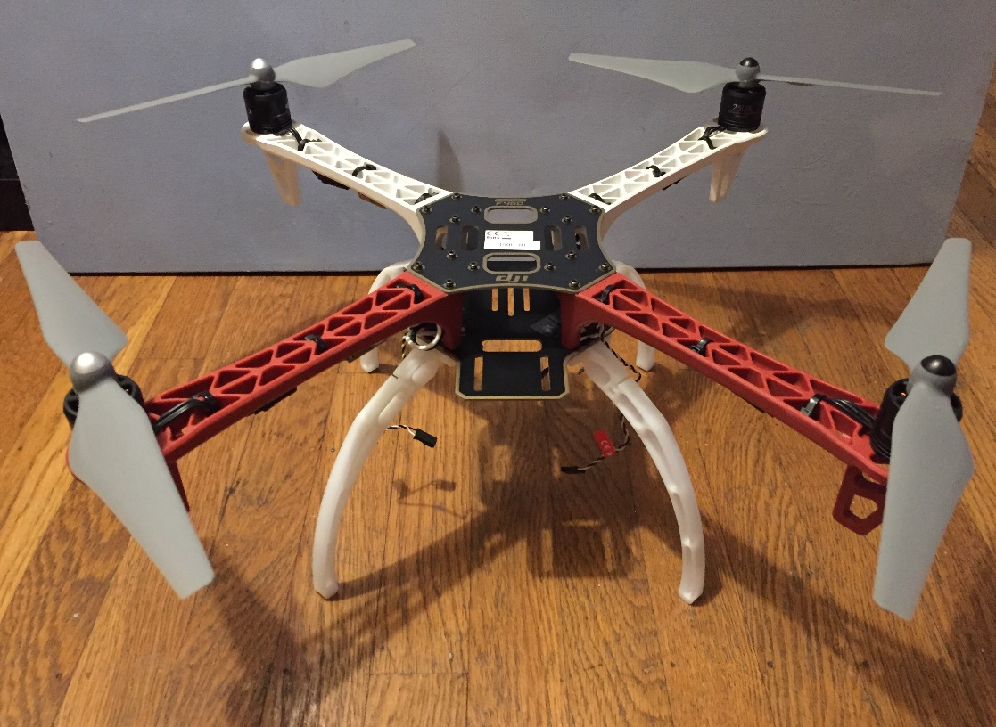

Figure 12: Then the propellers were attached.

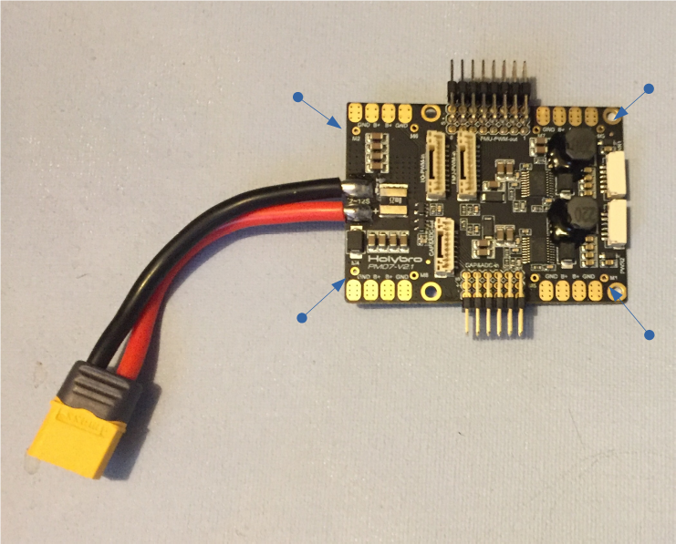

Figure : The ESC signal connections for the power management board have to be soldered on. The ESC connections from the motor are 3-pin 0.1" servo connectors with a twisted pair.

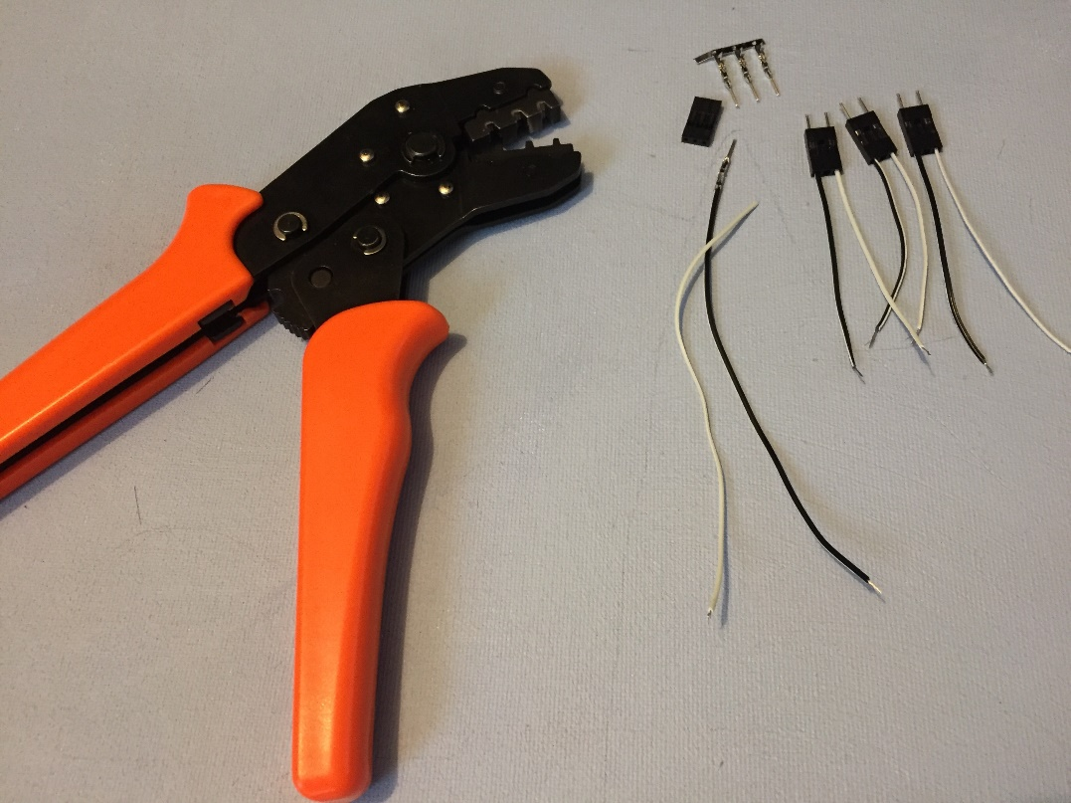

Figure : Instead of soldering the ESC connections directly to the PMB, custom cables were made to connect to the servo connectors from the ESC.

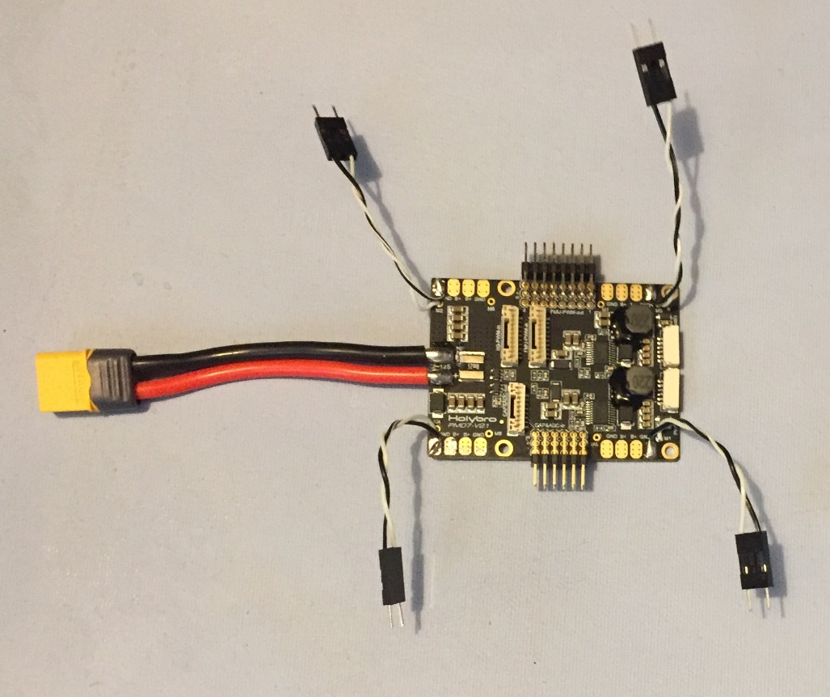

Figure : The cables were then soldered to the PMB.

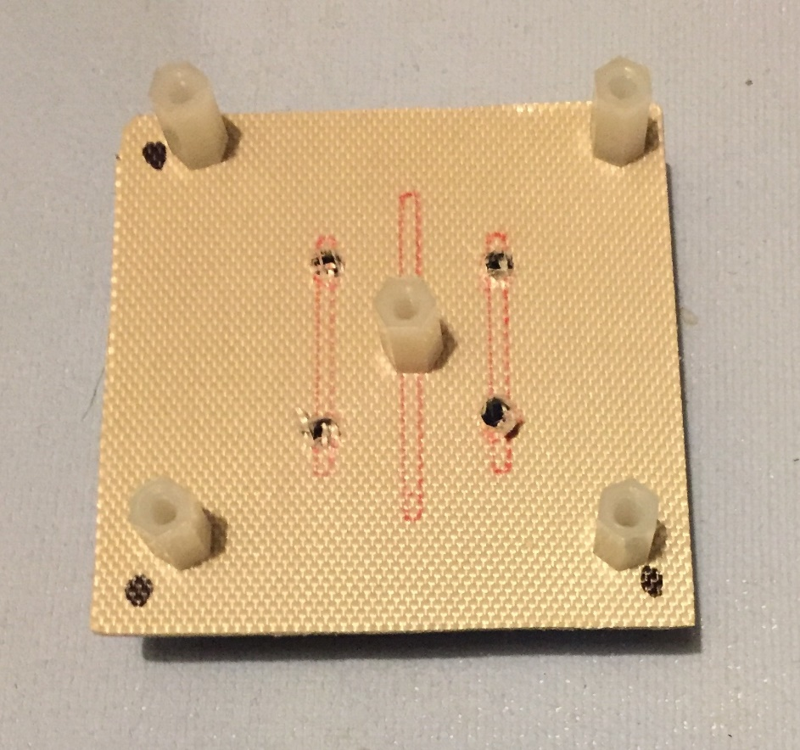

Figure : A custom carriage for the PMB was constructed from copper stripped FR4 laminate and nylon standoffs (Bottom View).

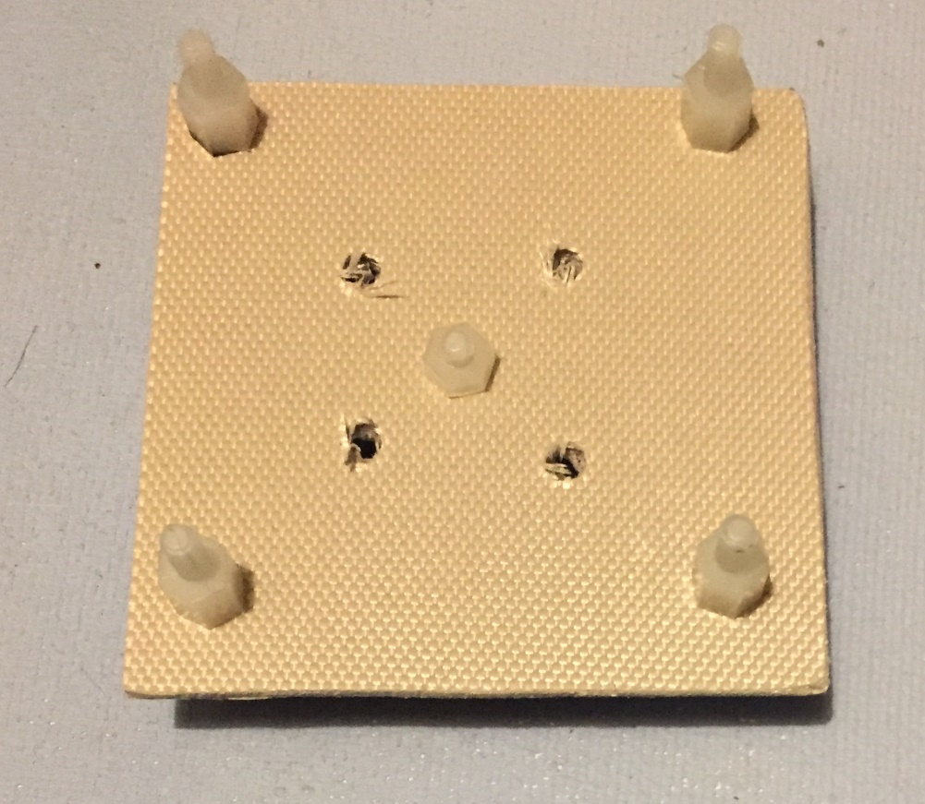

Figure : PMB carriage (Top View)

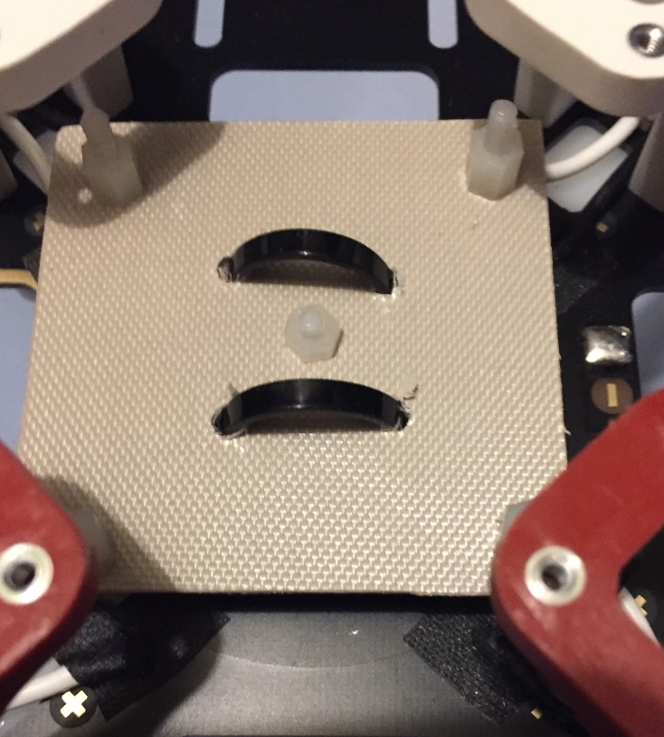

Figure : The PMB carriage was attached to the bottom plate in the middle of the F450 frame(Top View).

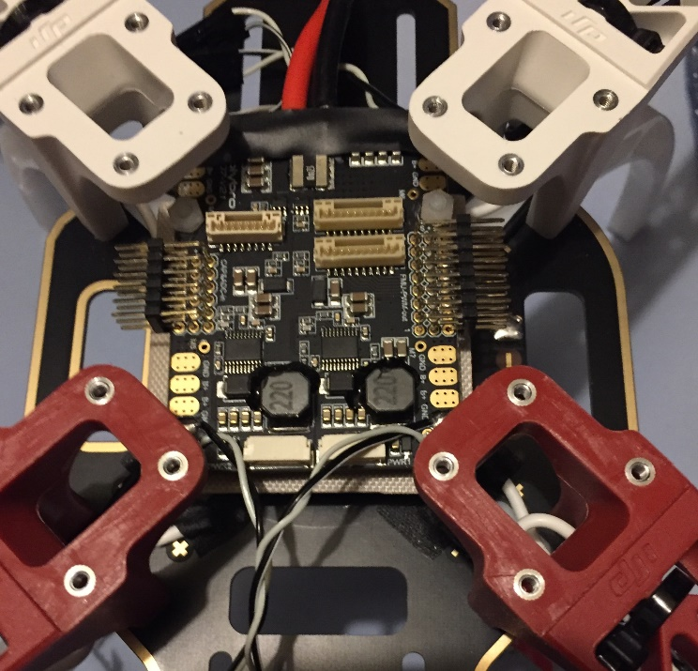

Figure : The PMB was then attached to the carriage.

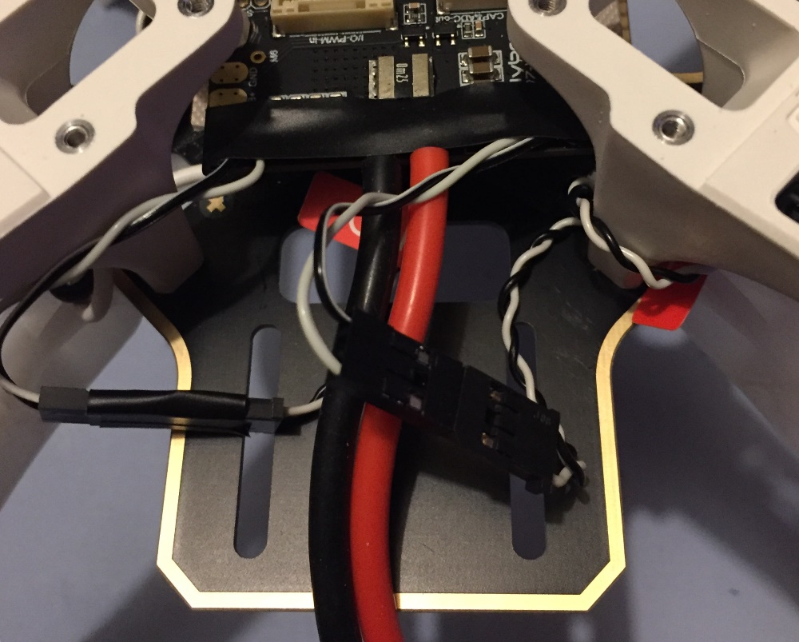

Figure : The ESC signals M1-4 were connected to the PMB.

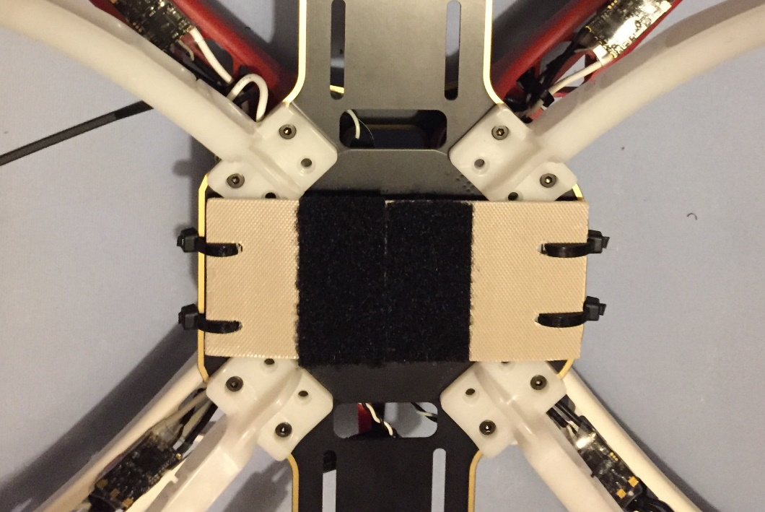

Figure : A battery carriage was created out of the same material with added velcro and zip tied to the bottom plate.

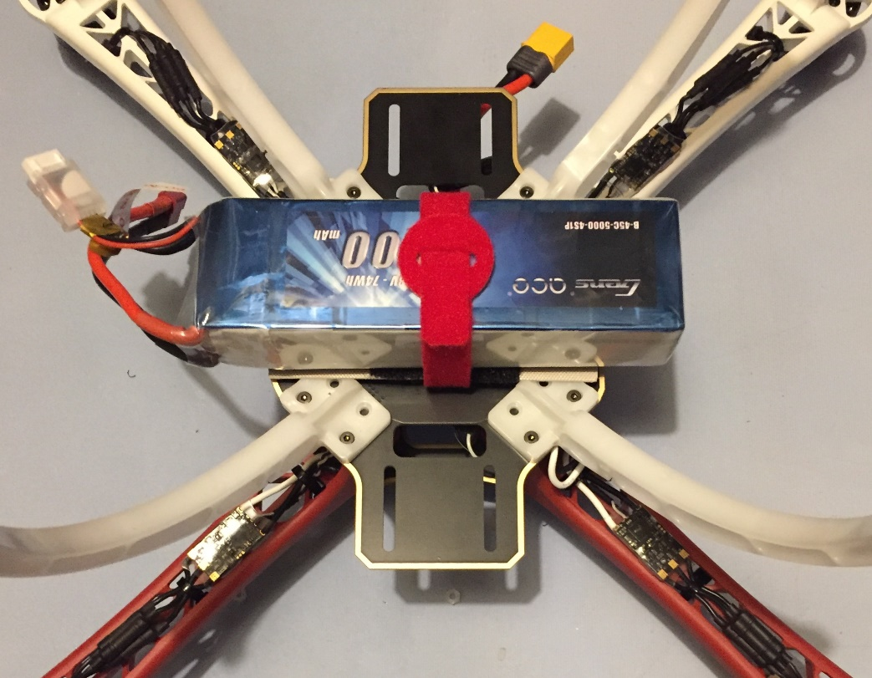

Figure : Battery attached to carriage with velcro and velcro strap

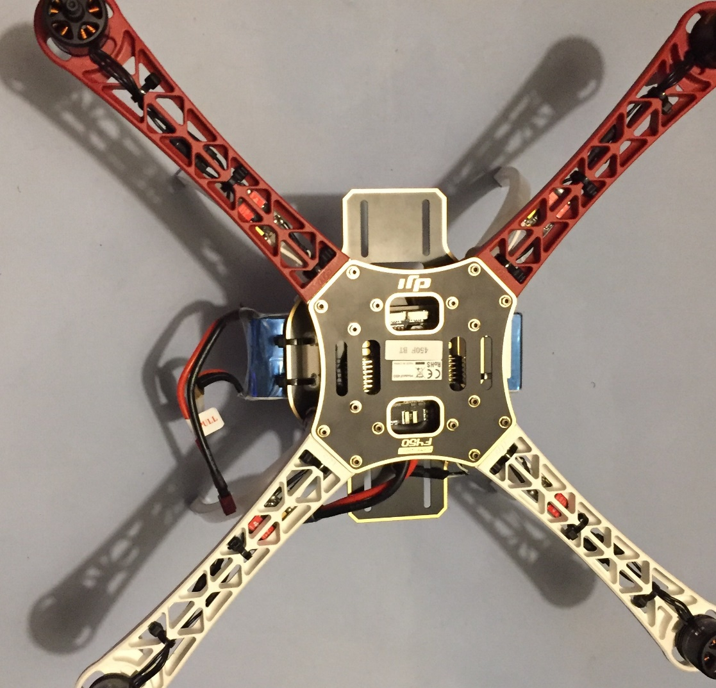

Figure : DJI F450 frame with motors, ESC, Pixhawk PMB, and battery installed

**SOFTWARE**

**.**

**.**

**.**